1

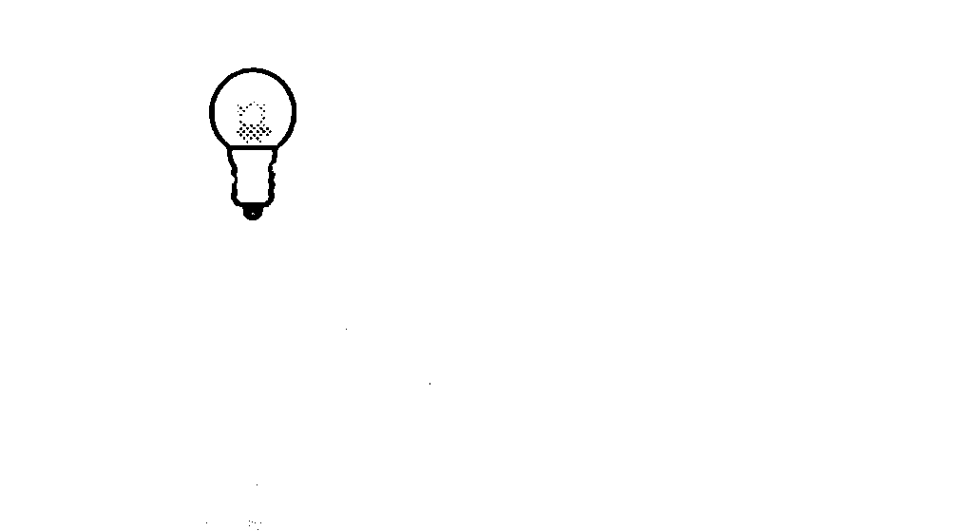  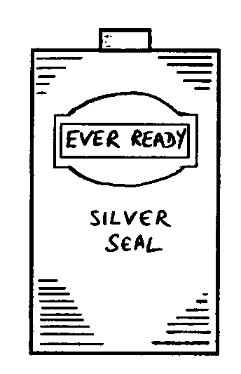  The two contact points on a torch battery are at the ends: |  | The two contact points on a torch bulb are the tip and the screw thread:

Look at the diagrams below. For each, tick one box () to show if the bulb is lit or not.

a. b. c.
.

not lit
lit
.

not lit
lit

.

not lit
lit

d. e. f.
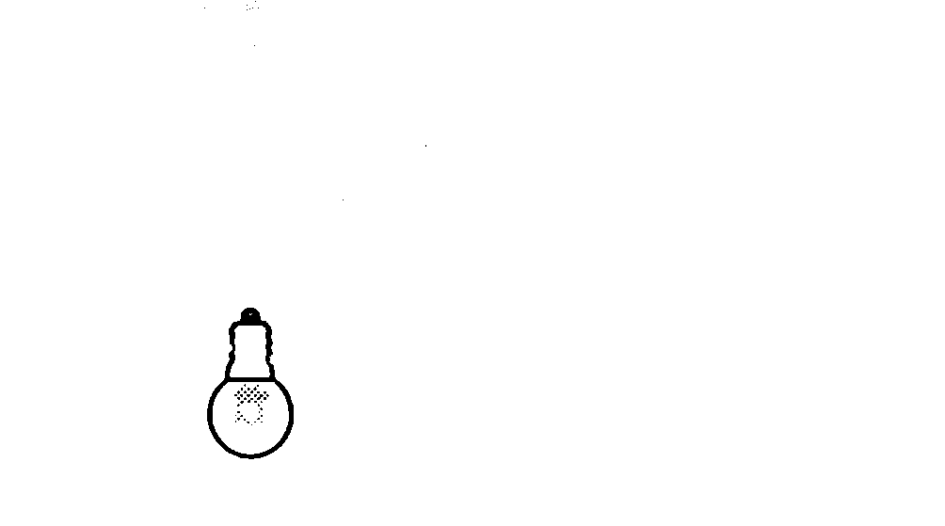
.

not lit
lit
.

not lit
lit
lit

not lit

.

